**Preparing a Data Analytics Portfolio**

Learning Goals

* **Define DA portfolio requirements**
* **Create a portfolio:**
  + **Gathering all the project pieces – Excel reports, presentations, GitHub**
  + **Creating wordpress/medium blog**
  + **Linking all projects to GitHub profile**

Introduction

It’s no secret the best jobs are the most sought after. The competition and screening one goes through to get the dream job with that big tech firm is fierce. This is the time where all of us have to be a salesman for ourselves. While a well written resume and LinkedIn profile can get a prospective employer’s attention, it us up to you to close the deal. A portfolio of your work in GitHub can help you do just that. A well-maintained data analytics portfolio can be shared with colleagues and prospective employers alike. It gives that big tech firm the ability to see for themselves you skills and experience you have. Your portfolio is a place where you can share your code or anything else related to any projects you have completed or participated in. You can start by uploading some of your work from this course, and add to it as you continue to develop yourself as a data analyst. A portfolio in GitHub is fairly easy to create. In this achievement, we will discuss the importance of having a portfolio in today’s job market, how to create a portfolio in GitHub, what should be included in your portfolio.

Start a Project

Login to your GitHub account you created as part of achievement 5.7. It’s best for whomever you wish to share your work that you create a repository in which to store your portfolio. This way you can direct whomever you are sharing with exactly where they can find which files you feel best highlight your experiences and skills. Go ahead and click on “New” button and create a repositor, just like you did in 5.7. Name the repository “MyPortfolio.” Now that you have a repository created and opened, the next thing you’ll need to do is start a project. From your homescreen, click on the + sign in the upper righthand side of your screen. Click on “New Project” on the drop down menu as shown in the image below. 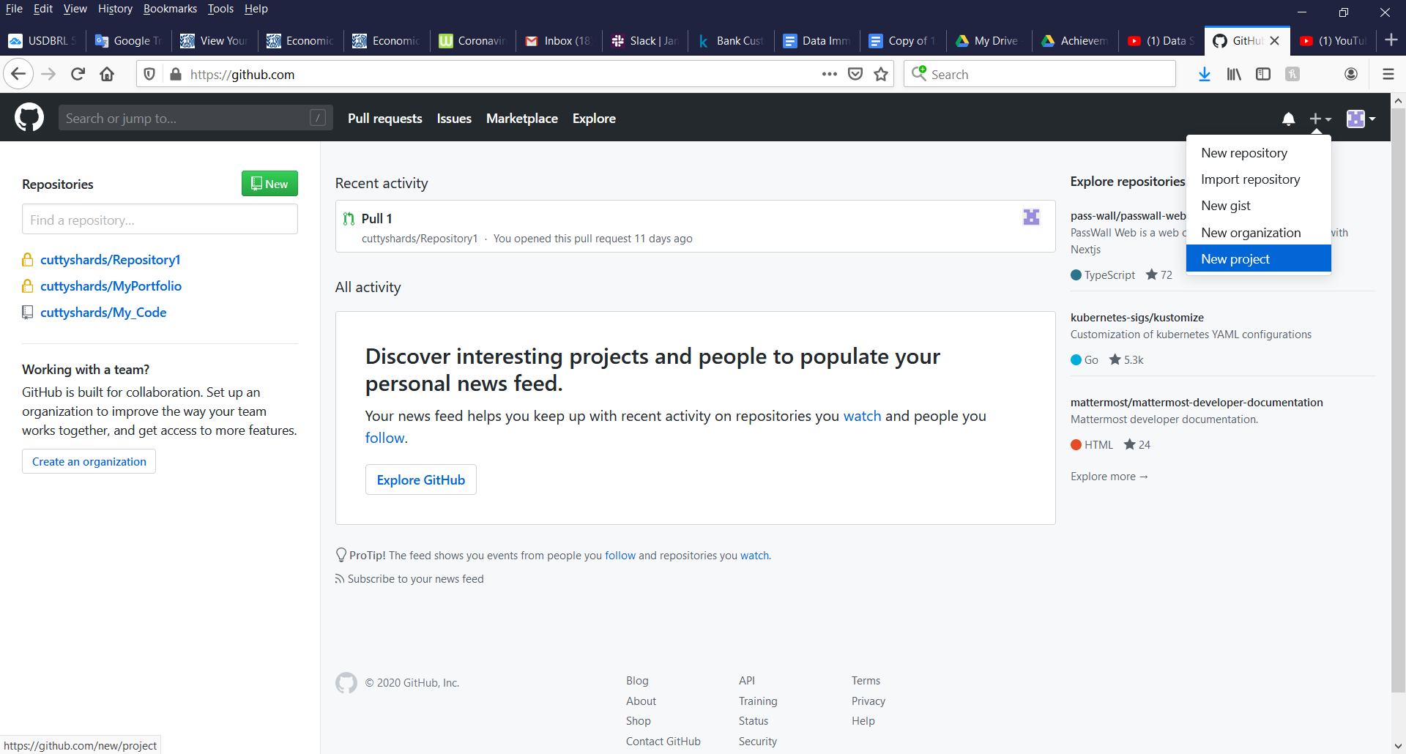

Next, you will need to give your project a name and give it a description. See image below.

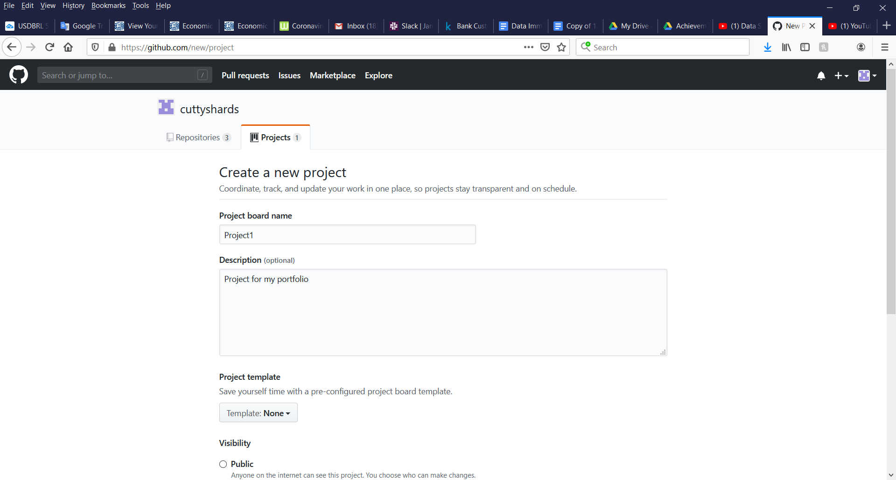

Finally, link your project to the repository you just created. Simply type in the name of the repository and choose it from the auto-suggest list. Once you choose the repository, you will see it below next to where it says “Linked Repositories.”

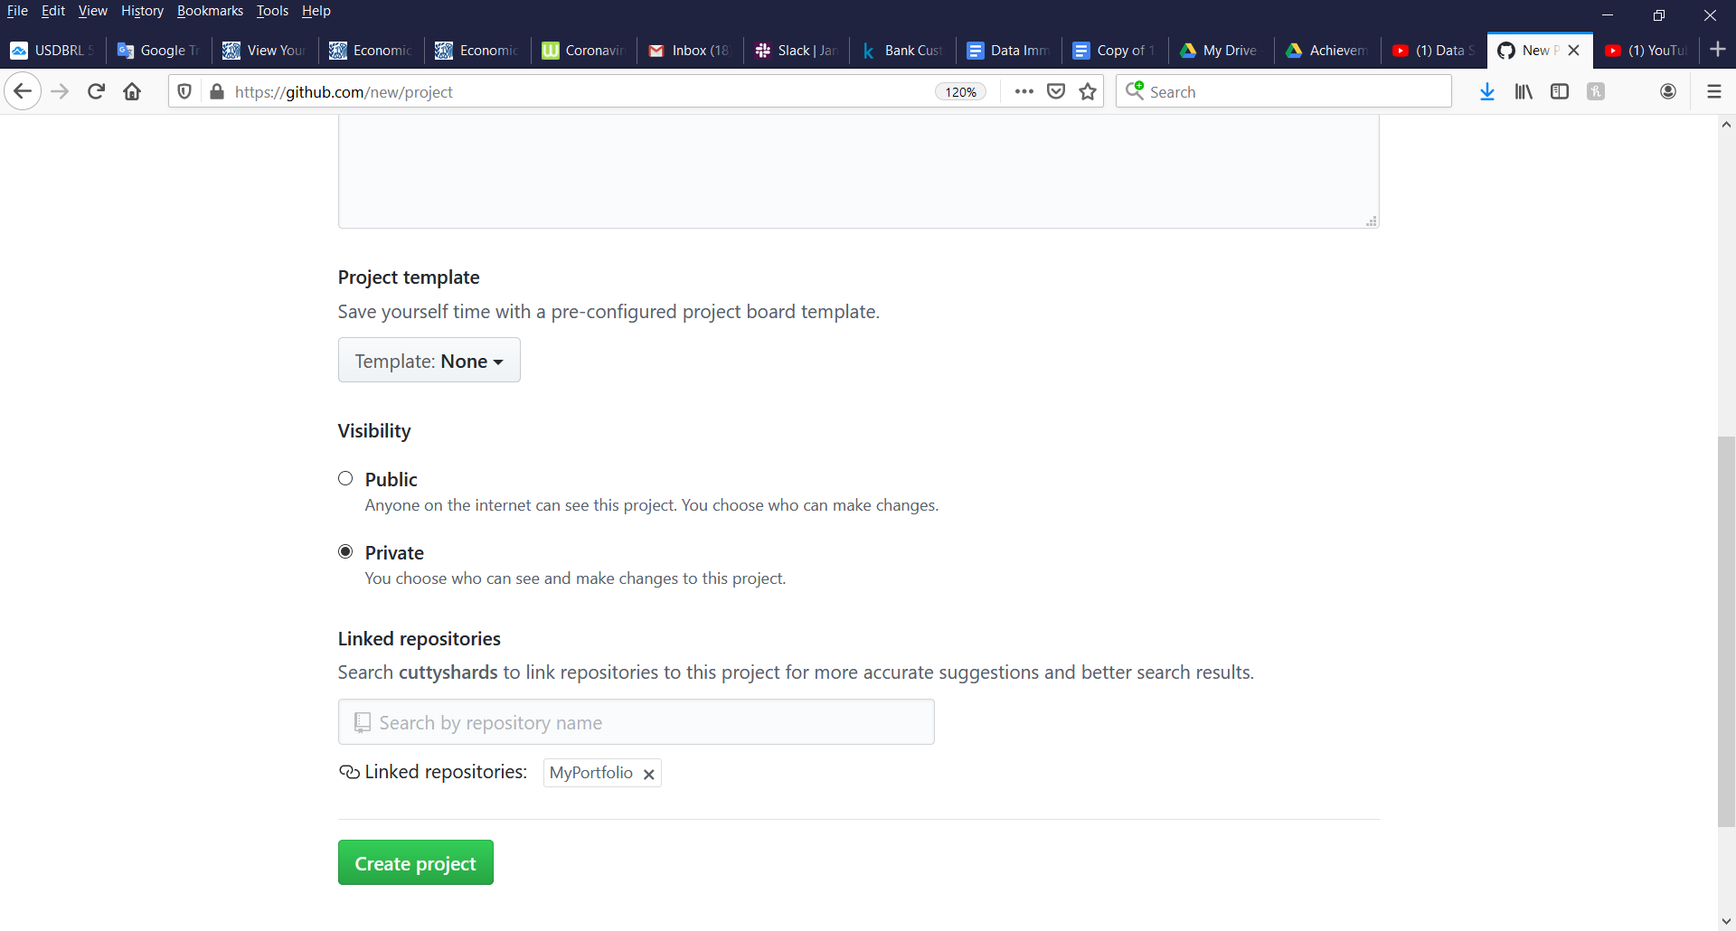

Now that your project has a name and place to reside, you can begin to work and upload your work. From your homescreen, click on the name of your project you will find in the upper left side of your screen. This will take you to the screen shown below. From here you can upload an existing file to your portfolio project by clicking “uploading an existing file” shown by the red arrow.

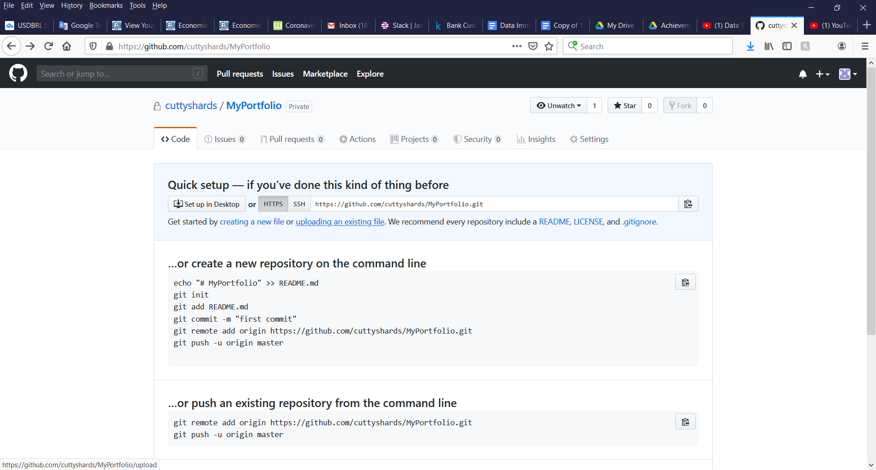

Drag files into your repository or click on “choose your files” to upload and select the files from your computer you’d like to share. Now you should see your file in your portfolio as shown below.

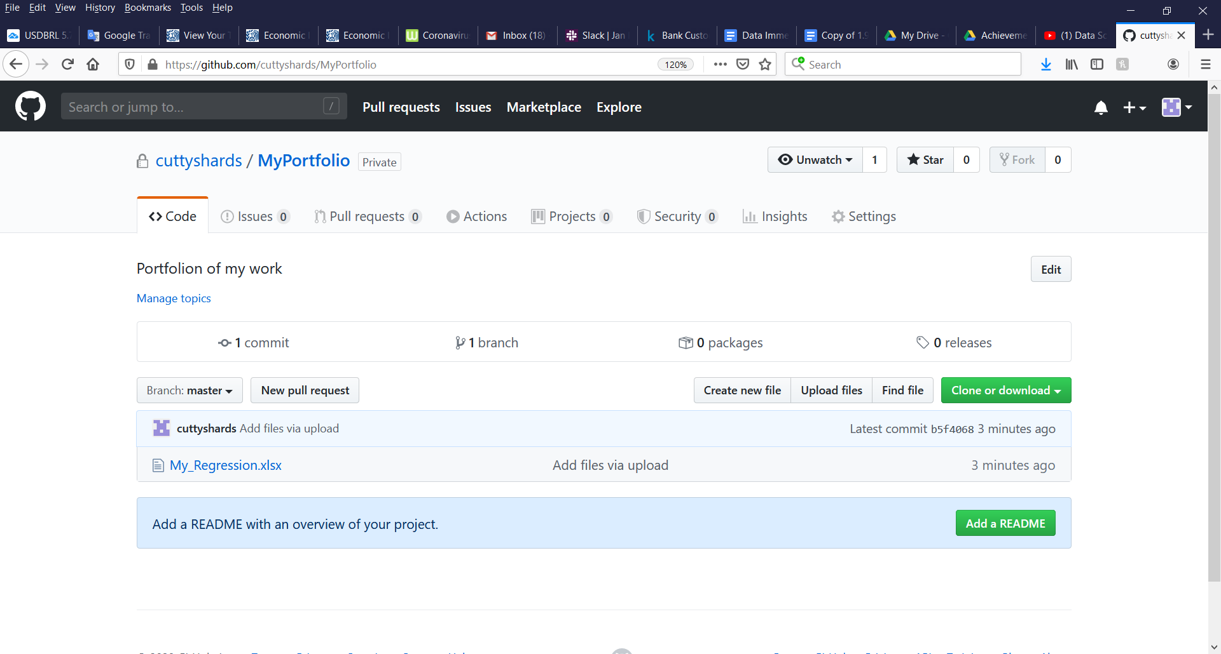

Portfolio Requirements

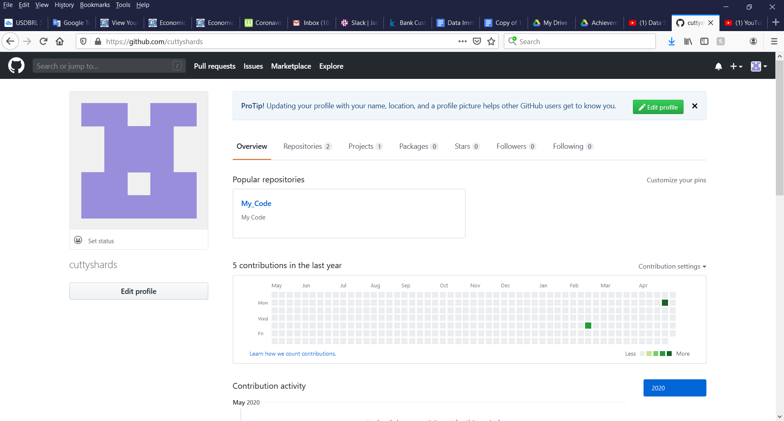

Create a Portfolio

Conclusion

Resources

Images